**INDEX**

1. Enter a list and print longest word.
2. Menu driven program to calculate the area.
3. Convert number into words.
4. Write a program to push items with the cost more than 75 to stack and display it’s count.
5. Print a list of the index value of all non zero numbers.
6. Print the count of the letter “E” and “T” both uppercase and lowercase in a string.
7. Print a new list by removing all the duplicate elements from the list.
8. Enter numbers and display sum of all even and odd numbers separately.
9. Write a menu driven program to push, pop and traverse stack.
10. Print a roll number list of all the students in class XI entered by user.
11. To find min of 1st half and max of 2nd half of a list entered by user.
12. Write a program to calculate median of given numbers by sorting the list first.
13. Write a program to print all the prime numbers upto number requested by the user.
14. Write a program to print the most frequent number in a list.
15. Calculate the sum of all numbers present in a string.
16. Calculate the total occurrence of a given character entered by a user.
17. Write a function to display the sum of all elements of a tupple.
18. Write a program to display the original list and reversed list without making a new list.
19. Enter a number and display if it’s Palindrome or not.
20. Enter a number and display if it’s Armstrong or not.
21. Create a text file and write two user defined functions- 1) To write data into the file, 2) To read data from the file and write the appropriate menu aswell.
22. Write a menu driven program with user defined functions to count number of Vowels, Lines and Consonants from file named Count.txt.
23. Write a menu driven program with user defined functions to Search line by a specific word or by a specific letter from file Search.txt.
24. To write user defined functions to enter movie id and movie name and another one to read data from the binary file Movie.dat and write the appropriate menu aswell.
25. To write a menu driven program with user defined functions to enter movie id and movie name in one go and update the data of the binary file Movie.dat.
26. To write user defined functions to add movie id and movie name at the end of the file and search the data from the movie id of the binary file Movie.dat with a menu.
27. Write two user defined functions with appropriate menu- 1) Accept()- where the user enters student id, student name, class and result[PASS or FAIL] and it is stored in a csv file named Result.csv. 2)PassCount()- Display the details student who have passed.
28. Write a menu driven program with user defined function to store details such as Ino, Item and Qty in Stock.csv and a function to display all the data stored in Stock.csv.
29. Write a menu driven program with user defined function to print items whose quantity is less than 150 to be reordered and a function to search details about an item by Ino in Stock.csv.
30. Write a menu driven program to demonstrate Add and Display performed on table student containing

(Name ,Class ,House) through mysql-python connectivity.

1. Write a menu driven program to Add data and Update data based on patient id on table appointment containing (Patient_ID, Name, Age, Date & Time) through mysql-python connectivity.
2. Write a menu driven program to Add details and Search for a particular record on table movie containing (Movie_ID, Movie_Name, Ticket_Price) through mysql-python connectivity.

Q11. To find min of 1st half and max of 2nd half of a list entered by user.

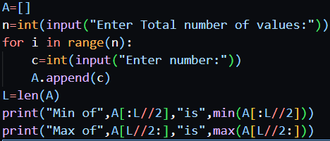

Output:

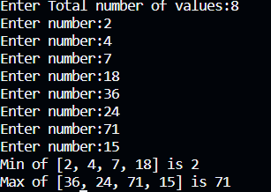

Q19. Enter a number and display if it’s Palindrome or not.

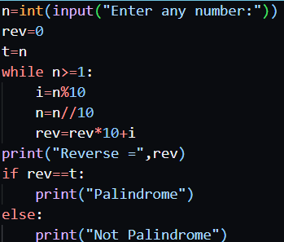

Output:



Q20. Enter a number and display if it’s Armstrong or not.

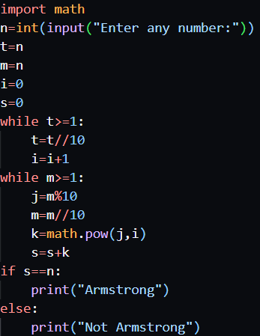

Output:



Q21. Create a text file and write two user defined functions- 1) To write data into the file, 2) To read data from the file and write the appropriate menu aswell.

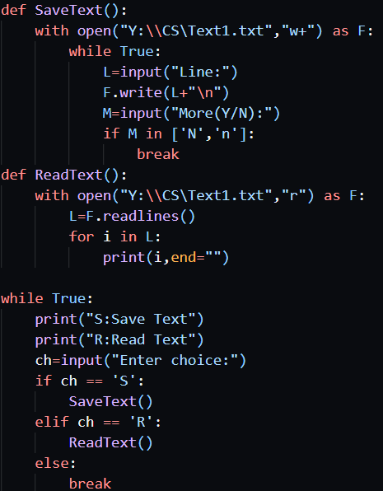

Output:

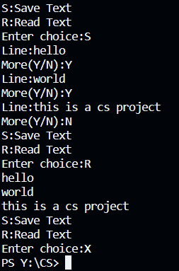

Q22. Write a menu driven program with user defined functions to count number of Vowels, Lines and Consonants from file named Count.txt.

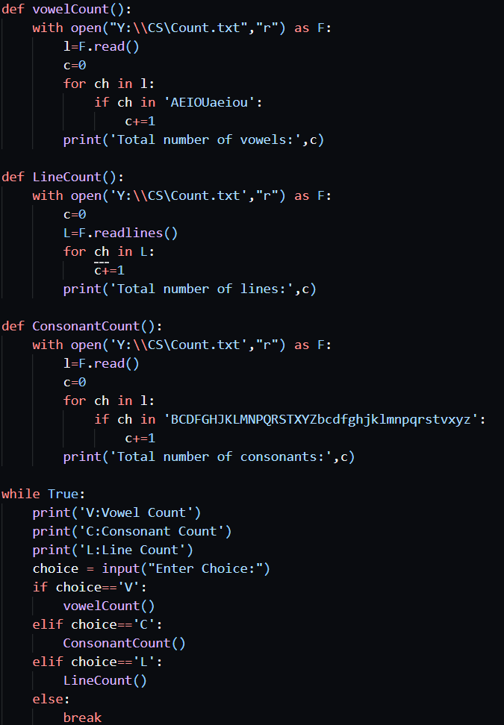

Contents of Count.txt:

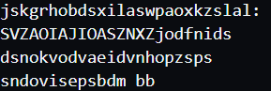

Output:

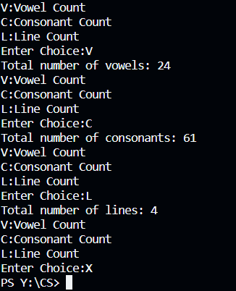

Q23. Write a menu driven program with user defined functions to Search line by a specific word or by a specific letter from file Search.txt.

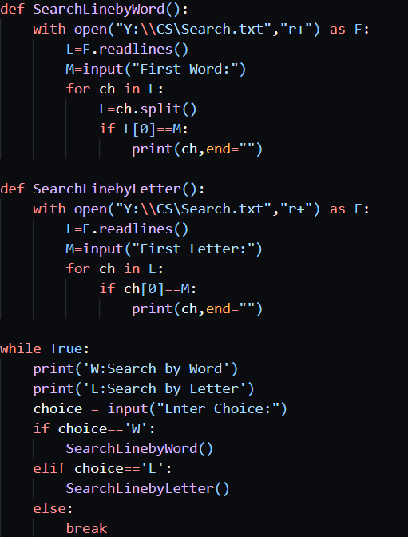

Contents of Search.txt:

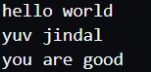

Output:

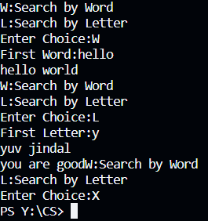

Q24. To write user defined functions to enter movie id and movie name and another one to read data from the binary file Movie.dat and write the appropriate menu aswell.

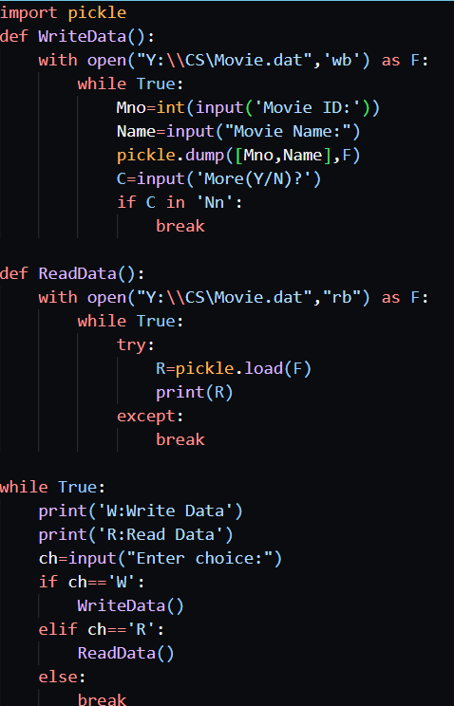

Output:

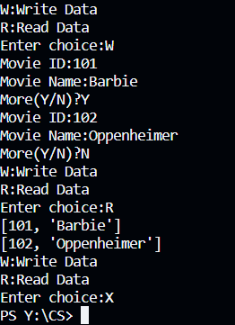

Q25. To write a menu driven program with user defined functions to enter movie id and movie name in one go and update the data of the binary file Movie.dat.

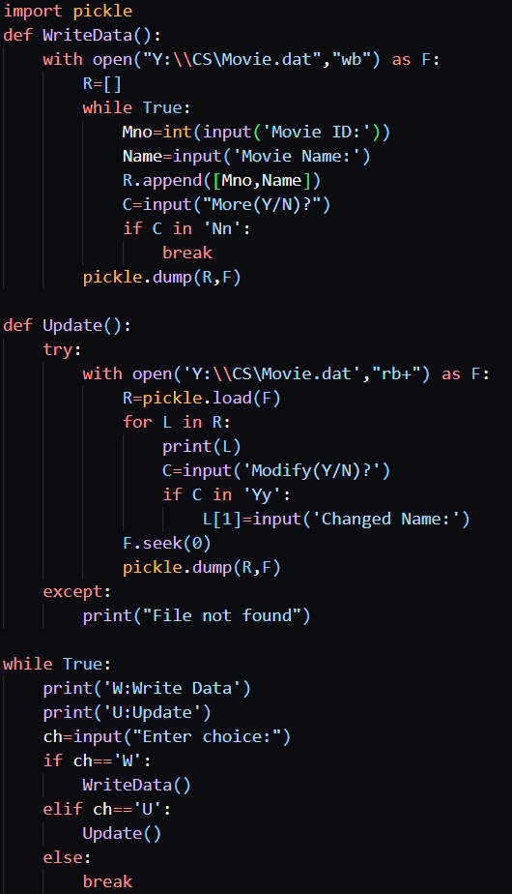

Output:

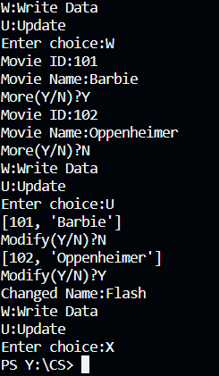

Q26. To write user defined functions to add movie id and movie name at the end of the file and search the data from the movie id of the binary file Movie.dat with a menu.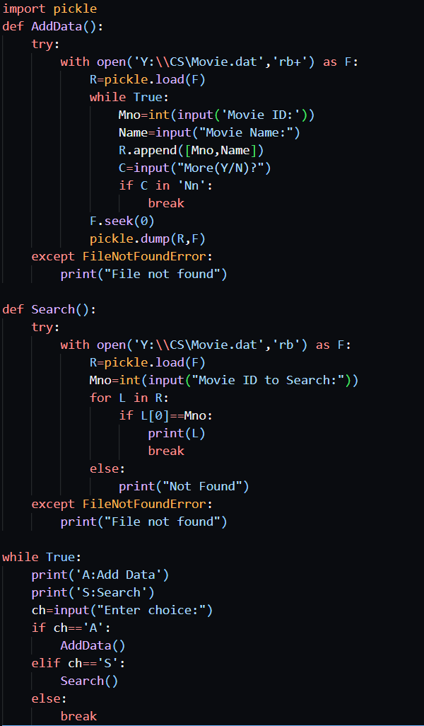

Output:

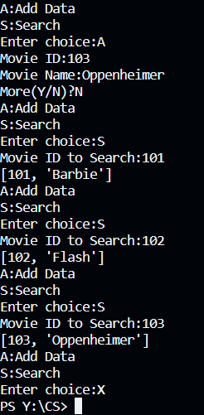

Q27. Write two user defined functions with appropriate menu- 1) Accept()- where the user enters student id, student name, class and result[PASS or FAIL] and it is stored in a csv file named Result.csv. 2)PassCount()- Display the details student who have passed.

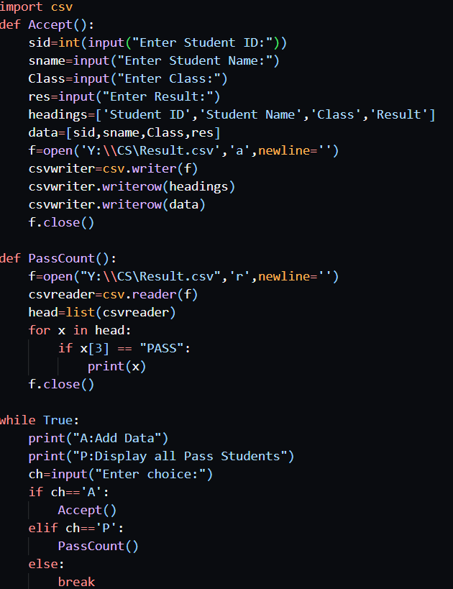

Output:

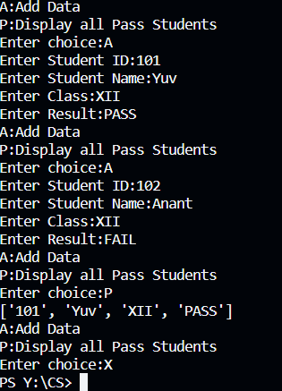

Q28. Write a menu driven program with user defined function to store details such as Ino, Item and Qty in Stock.csv and a function to display all the data stored in Stock.csv.

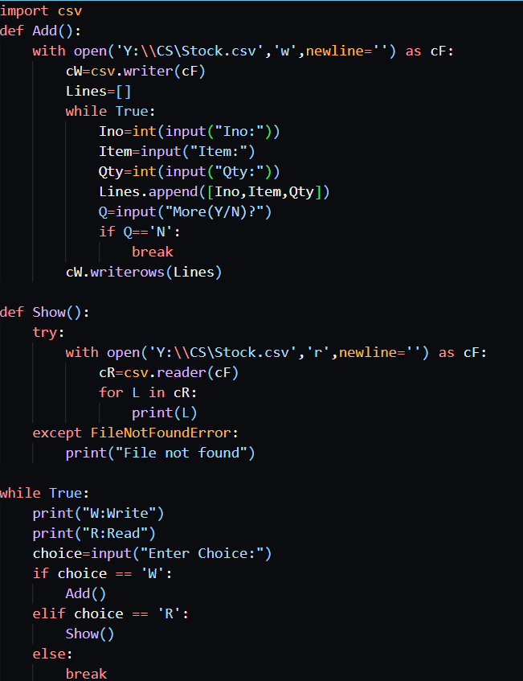

Output:

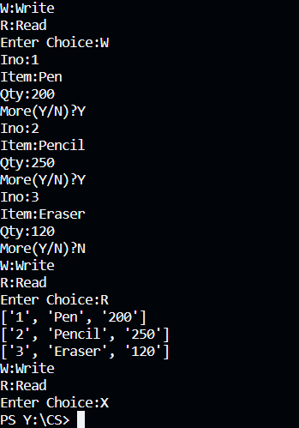

Q29. Write a menu driven program with user defined function to print items whose quantity is less than 150 to be reordered and a function to search details about an item by Ino in Stock.csv.

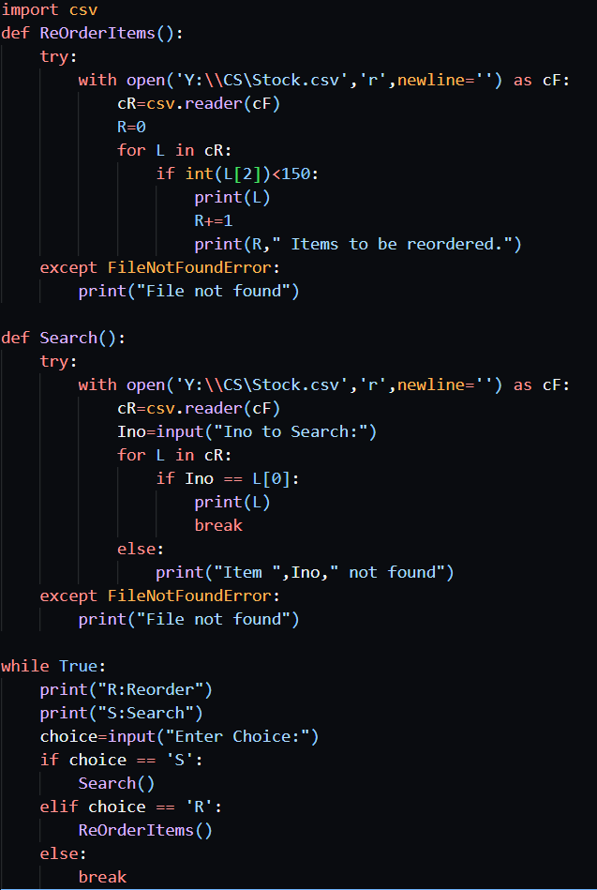

Output:

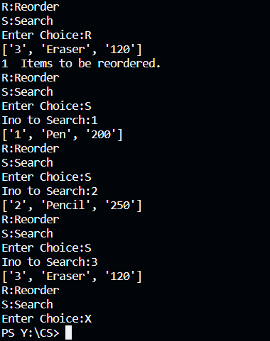

Q30. Write a menu driven program to demonstrate Add and Display performed on table student containing (Name ,Class ,House) through mysql-python connectivity.

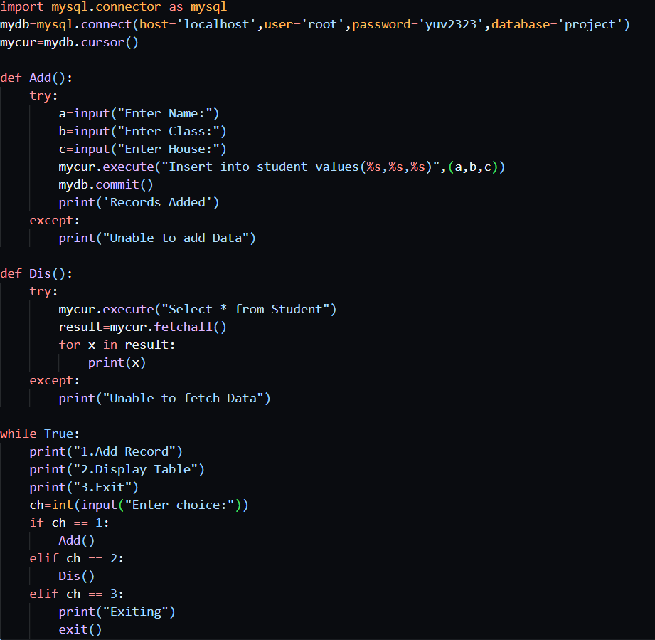

Output:

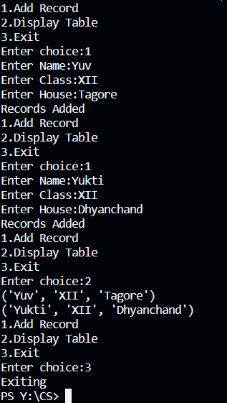

Q31. Write a menu driven program to Add data and Update data based on patient id on table appointment containing (Patient_ID, Name, Age, Date & Time) through mysql-python connectivity.

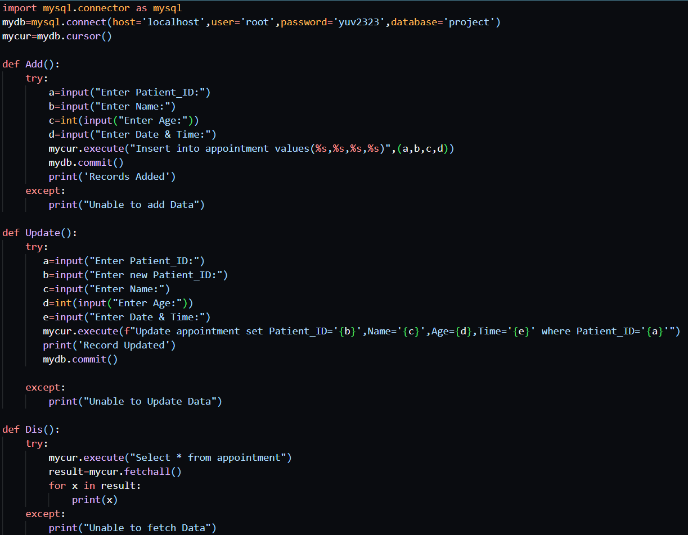

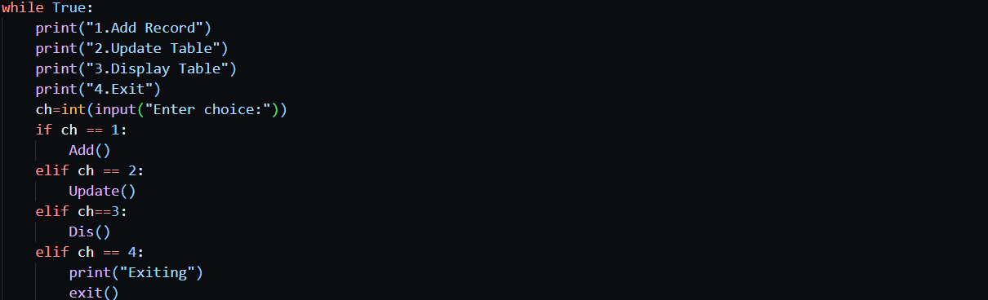

Output:

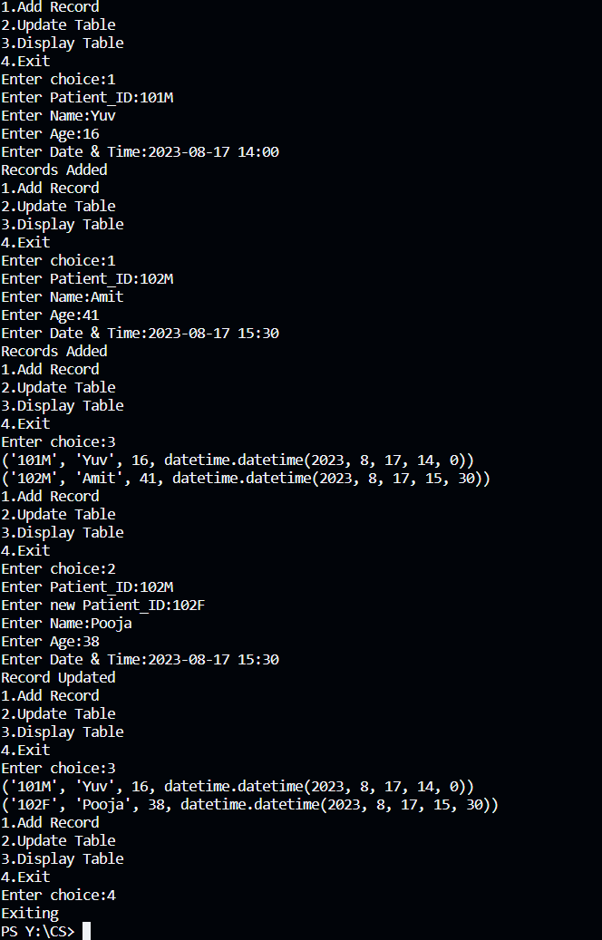

Q32. Write a menu driven program to Add details and Search for a particular record on table movie containing (Movie_ID, Movie_Name, Ticket_Price) through mysql-python connectivity.

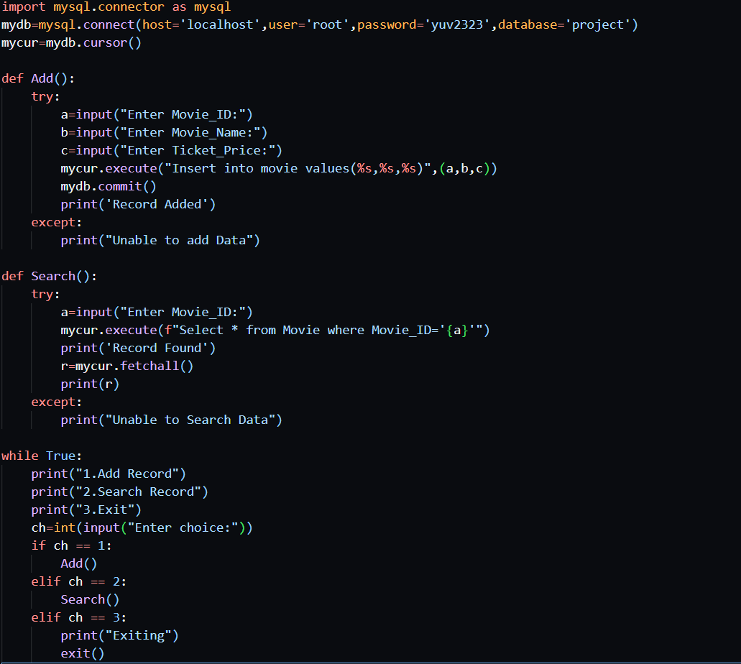

Output:

